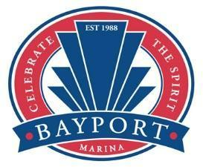
Bayport Marina Association
Board of Directors Meeting
Thursday, August 21, 2025
6:00 PM – 6:30 PM

Member | Present | Absent
John Gagich | X
Betsy Steiner | X
Dave Peterka |  | X
Jim Geisler | X
Rob Rueckl | X
BJ Battig | X
Todd Rosengren | X
Bryan Wilkinson | X
BMA staff present
Kori Derrick-Cisewski | X
Ellsa Hermansen | X
Nick Lutfi | X

- Check in

Meeting called to order at 6:07 pm by Todd Rosengren, confirmed a quorum was present.

- Consent agenda – discussion/approval
- Motion to approve consent agenda and July minutes by BJ Battig, Jim Geisler second. All approved.
- Comment was made that the budget is tight for the balance of the year.
- Incident Report about Marijuana Fumes at the marina was discussed.
- Slip rental rate to increase by 3% for 2026

- Stewardship circles status
  - Improving Access to Docks – Work is temporarily on hold while we wait for river levels to go down because of where the platform is located. Currently the sidewalk is roughed in.
  - Wi-Fi – The Wi-Fi committee met to review the Membership Survey. Most people do choose to use the Wi-Fi provided, but no one has much positive to say about it. We are going to be looking into a cellular meshed network that could be offered by T-Mobile or AT&T.

- Other business
The hearing for the TRO was on August 1 and the judge has up to 90 days to make a decision about if it will be granted. The judge seemed to favor the LA Group’s side, but the fact that we haven’t heard a decision yet is possibly a good sign.

- Member forum

No discussion this month.

- Executive session

No discussion this month.

- Adjourn

Motion to adjourn by Rob Rueckl, 6:25 pm.

Transitioned to the Past Commodores’ Reception attended by the following Past Commodores:
- Curt Gray
- Russell Sheaffer
- Marcus Gernes
- Morgan Fudge
- Ron Tortelli
- Eric Pederson
- Brien Slawik
- Amy Tolbert
- Val Fuller
- Meredith Pederson
- Tore Detlie

